Lab 2: Binary Combinational Array Multiplier Design, Sequential Multiplier Design

CPE 166/EEE 270 Advanced Logic Design Lab

Lab Session: Wednesday 2:00 – 4:40

Section: 02

Daniel Komac

Table of Contents

**Introduction:** **3**

**Part 1: Combinational Logic Multiplier** **4**

Source Code:Half Adder 4

Source Code:Full Adder 6

Four by Four Multiplier: 8

**Part 2: 4 by 4 Binary Sequential Multiplier Design** **13**

Source Code:Adder 13

Source Code:D Flip-Flop A 13

Source Code: D Flip-Flop B 15

Source Code: FSM 16

Source code: Mult (Multiplier) 23

Source code: Mux 24

Source code: Top Module 26

**Part 3: LCD** **28**

Source Code: LCD 28

**Conclusion:** **32**

# 

# Introduction:

This lab explores two different ways to create a 4 by 4-binary multiplier in Verilog. Broken into two parts, Part 1 will use combinational logic while Part 2 will use sequential logic to create the multiplier. A time-independent digital circuit implemented using logic gates whose output depends solely on its inputs may be considered to be using combinational logic. A digital circuit using sequential logic will have an output that is dependent on the inputs as well as what state the circuit is in. Both programs can take two 4 bit binary numbers and return an 8-bit number that is the result of the two numbers multiplied together. A hierarchical design will be used to implement both programs. A top-level method will be made up of various lower level methods to create the multipliers. Every method will be created and tested individually, where they will eventually be linked together by a higher-level module. Using a hierarchical design, the top level module will be neat and easy understand; given two 4-bit inputs, the 8-bit output will be the two inputs multiplied. Then at the very end, the lap explores on how to display letters on the LCD from using verilog code. The lab serves as an introduction for writing modules in Verilog as well as creating test benches in Verilog to verify the modules are working through simulation. The waveforms from the simulations will be analyzed to show the module is working as intended.

# Part 1: Combinational Logic Multiplier

## Source Code:Half Adder

--Author: Xue Eric Lee

--Date: 4/10/2018

--File Name: HalfAdder.v

--Purpose of Code:Show the half adder logic.

--Project Part Number: Part 1 – A

module HalfAdder(a,b,c_out,s);

input a,b;

output c_out,s;

assign s = a^b;

assign c_out = a&b;

endmodule

--Author: Xue Eric Lee

--Date: 4/10/2018

--File Name: halfAdder_tb.v

--Purpose of Code:Test the half adder logic.

--Project Part Number: Part 1 – A

module halfadder_tb; //test batch

reg ta, tb;

wire tcout, tsum;

halfAdder u1 (.a(ta), .b(tb), .c_out(tc_out), .s(ts)); //name association

initial

begin

begin ta = 0; tb = 0;

#10; ta = 0; tb = 1;

#10; ta = 1; tb = 0;

#10; ta = 1; tb = 1;

#10 $stop;

end

endmodule

Simulation Waveform:

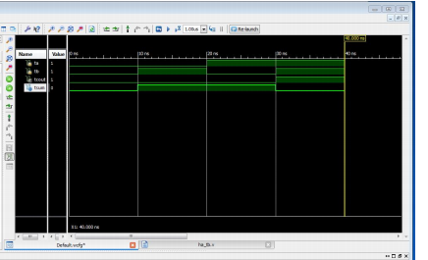

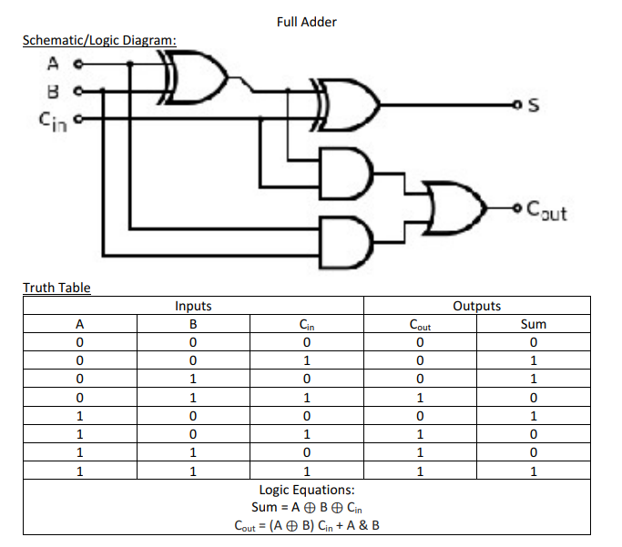

## Source Code:Full Adder

--Author: Xue Eric Lee

--Date: 4/10/2018

--File Name: FullAdder.v

--Purpose of Code:Show the Full adder logic.

--Project Part Number: Part 1 – B

module FullAdder(a,b,cin,cout,s);

input a,b,c_in;

wire m,n,p;

output s,c_out;

HalfAdder i1(.a(a),.b(b),.cout(n),.s(m));

HalfAdder i2(.a(cin),.b(m),.cout(p),.s(s));

assign c_out = n|p;

endmodule

--Author: Xue Eric Lee

--Date: 4/10/2018

--File Name: FullAdder_tb.v

--Purpose of Code:Test the Full adder logic.

--Project Part Number: Part 1 – B

Module fulladder_tb;

Reg a, b, cin; wire cout, sum;

FullAdder u3(.a(a),.b(b),.cin(cin),.cout(cout), .s(s));

initial

begin

a=0;b=0;cin=0;

#10 a=0;b=0;cin=1;

#10;a=0;b=1;cin=0;

#10;a=0;b=1;cin=1;

#10;a=1;b=0;cin=0;

#10;a=1;b=0;cin=1;

#10;a=1;b=1;cin=0;

#10;a= 1;b=1;cin=1;

#10$stop;

end

endmodule

Simulation Waveform:

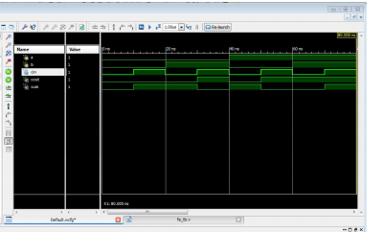

## Four by Four Multiplier:

Schematic / Logic Diagram:

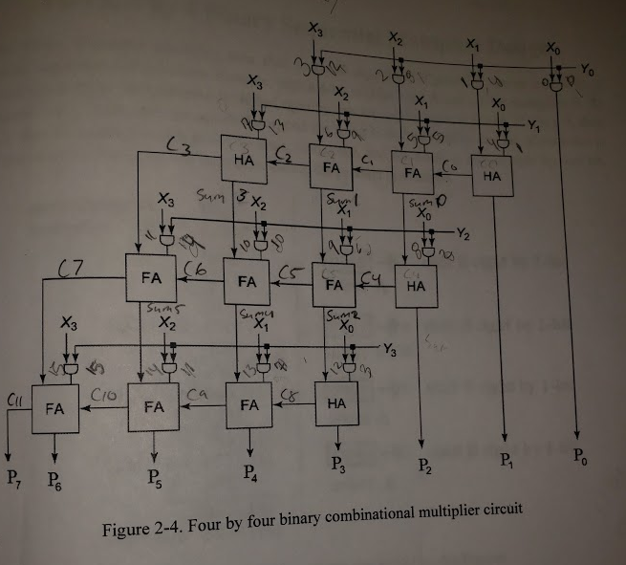

Truth Table:

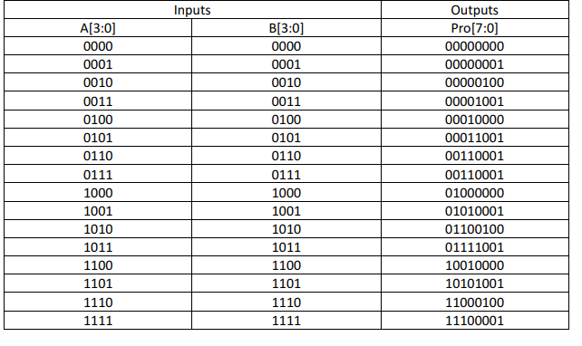

Source Code:

--Author: Xue Eric Lee

--Date: 4/10/2018

--File Name: myMulti.v

--Purpose of Code:Show the four by four combinational multiplexer logic

--Project Part Number: Part 1 – C

module myMulti(x,y,p);

input [3:0] x,y;

output [7:0] p;

wire [15:0] andRes;

wire [10:0] c;

wire [5:0] sum;

assign andRes[0] = y[0] & x[0];

assign andRes[1] = y[1] & x[0];

assign andRes[2] = y[2] & x[0];

assign andRes[3] = y[3] & x[0];

assign andRes[4] = y[0] & x[1];

assign andRes[5] = y[1] & x[1];

assign andRes[6] = y[2] & x[1];

assign andRes[7] = y[3] & x[1];

assign andRes[8] = y[0] & x[2];

assign andRes[9] = y[1] & x[2];

assign andRes[10] = y[2] & x[2];

assign andRes[11] = y[3] & x[2];

assign andRes[12] = y[0] & x[3];

assign andRes[13] = y[1] & x[3];

assign andRes[14] = y[2] & x[3];

assign andRes[15] = y[3] & x[3];

//First place output

assign p[0] = andRes[0];

//Second place output

HalfAdder add1(.a(andRes[1]), .b(andRes[4]),.c_out(c[0]),.s(p[1]));

//Third place output

FullAdder fAdd1(.a(andRes[8]),.b(andRes[5]),.c_in(c[0]),.c_out(c[1]),.s(sum[0]));

HalfAdder add2(.a(sum[0]),.b(andRes[2]),.c_out(c[4]),.s(p[2]));

//Fourth Place output

FullAdder fAdd2(.a(andRes[9]),.b(andRes[12]),.c_in(c[1]),.c_out(c[2]),.s(sum[1]));

FullAdder fAdd3(.a(sum[1]),.b(andRes[6]),.c_in(c[4]),.c_out(c[5]),.s(sum[2]));

HalfAdder add3(.a(andRes[3]),.b(sum[2]),.c_out(c[8]),.s(p[3]));

//Fifth Place output

HalfAdder add4(.a(andRes[13]),.b(c[2]),.c_out(c[3]),.s(sum[3]));

FullAdder fAdd4(.a(sum[3]),.b(andRes[10]),.c_in(c[5]),.c_out(c[6]),.s(sum[4]));

FullAdder fAdd5(.a(sum[4]),.b(andRes[13]),.c_in(c[8]),.c_out(c[9]),.s(p[4]));

//Sixth Place output

FullAdder fAdd6(.a(andRes[14]),.b(c[3]),.c_in(c[6]),.c_out(c[7]),.s(sum[5]));

FullAdder fAdd7(.a(andRes[11]),.b(c[9]),.c_in(sum[5]),.c_out(c[10]),.s(p[5]));

//Seventh Place output && Eighth Place output

FullAdder fAdd8(.a(andRes[15]),.b(c[7]),.c_in(c[10]),.c_out(p[7]),.s(p[6]));

endmodule

--Author: Xue Eric Lee

--Date: 4/10/2018

--File Name: multi_tb.v

--Purpose of Code:test the four by four combinational multiplexer logic

--Project Part Number: Part 1 – C

module multi_tb;

reg [3:0] x,y;

wire [7:0] p;

//myMulti t1(.x(x),.y(y),.p(p));

initial

begin

x=4'b1011;

y=4'b1101;

#20 $stop;

end

endmodule

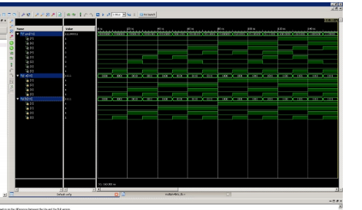

User Constraints File:

##Switches

set_property -dict { PACKAGE_PIN J15 IOSTANDARD LVCMOS33 } [get_ports {x[0]}]; #IO_L24N_T3_RS0_15 Sch=sw[0]

set_property -dict { PACKAGE_PIN L16 IOSTANDARD LVCMOS33 } [get_ports {x[1]}]; #IO_L3N_T0_DQS_EMCCLK_14 Sch=sw[1]

set_property -dict { PACKAGE_PIN M13 IOSTANDARD LVCMOS33 } [get_ports {x[2]}]; #IO_L6N_T0_D08_VREF_14 Sch=sw[2]

set_property -dict { PACKAGE_PIN R15 IOSTANDARD LVCMOS33 } [get_ports {x[3]}]; #IO_L13N_T2_MRCC_14 Sch=sw[3]

set_property -dict { PACKAGE_PIN R17 IOSTANDARD LVCMOS33 } [get_ports { y[0] }]; #IO_L12N_T1_MRCC_14 Sch=sw[4]

set_property -dict { PACKAGE_PIN T18 IOSTANDARD LVCMOS33 } [get_ports { y[1] }]; #IO_L7N_T1_D10_14 Sch=sw[5]

set_property -dict { PACKAGE_PIN U18 IOSTANDARD LVCMOS33 } [get_ports { y[2] }]; #IO_L17N_T2_A13_D29_14 Sch=sw[6]

set_property -dict { PACKAGE_PIN R13 IOSTANDARD LVCMOS33 } [get_ports { y[3] }]; #IO_L5N_T0_D07_14 Sch=sw[7]

## LEDs

set_property -dict { PACKAGE_PIN H17 IOSTANDARD LVCMOS33 } [get_ports { p[0] }]; #IO_L18P_T2_A24_15 Sch=led[0]

set_property -dict { PACKAGE_PIN K15 IOSTANDARD LVCMOS33 } [get_ports { p[1] }]; #IO_L24P_T3_RS1_15 Sch=led[1]

set_property -dict { PACKAGE_PIN J13 IOSTANDARD LVCMOS33 } [get_ports { p[2] }]; #IO_L17N_T2_A25_15 Sch=led[2]

set_property -dict { PACKAGE_PIN N14 IOSTANDARD LVCMOS33 } [get_ports { p[3] }]; #IO_L8P_T1_D11_14 Sch=led[3]

set_property -dict { PACKAGE_PIN R18 IOSTANDARD LVCMOS33 } [get_ports { p[4] }]; #IO_L7P_T1_D09_14 Sch=led[4]

set_property -dict { PACKAGE_PIN V17 IOSTANDARD LVCMOS33 } [get_ports { p[5] }]; #IO_L18N_T2_A11_D27_14 Sch=led[5]

set_property -dict { PACKAGE_PIN U17 IOSTANDARD LVCMOS33 } [get_ports { p[6] }]; #IO_L17P_T2_A14_D30_14 Sch=led[6]

set_property -dict { PACKAGE_PIN U16 IOSTANDARD LVCMOS33 } [get_ports { p[7] }]; #IO_L18P_T2_A12_D28_14 Sch=led[7]

Results:

In this part of the lab, we were able to get our expected values from the 4 by 4 combination multiplier design. In this part there were not too much trouble except that we had to work slow and methodically. As long as we drew out and wrote on the schematic of what we need we were able to accomplish our goals. In this part, we finished quickly but ended up getting stuck for hours because of a small error in our code, in which after many gruely tries were able to find out what was bugging our code.

# Part 2: 4 by 4 Binary Sequential Multiplier Design

## Source Code:Adder

--Author: Xue Eric Lee

--Date: 4/10/2018

--File Name: adder.v

--Purpose of Code:Adds register B and A together

--Project Part Number: Part 2a

module adder( a, b, cout, s);

input [3:0] a, b;

output cout;

output [3:0] s;

assign {cout, s} = a+b;

endmodule

## Source Code:D Flip-Flop A

--Author: Xue Eric Lee

--Date: 4/10/2018

--File Name: dffa.v

--Purpose of Code:Load a number into A register

--Project Part Number: Part 2b

module dffa (clk,clr, load, da, qa);

input clk, clr, load;

input [3:0] da;

output [3:0] qa;

reg [3:0] qa;

always@(posedge clr or posedge clk)

begin

if(clr) qa <= 0;

else if (load)

qa <= da;

end

endmodule

Source Code: D Flip-Flop A Testbench

--Author: Xue Eric Lee

--Date: 4/10/2018

--File Name: dffa_tb.v

--Purpose of Code:Test flip flop

--Project Part Number: Part 2b

`timescale 1ns/1ps

module dffa_tb;

reg clk, clr, load;

reg [3:0] da;

wire [3:0] qa;

dffa uut (.clk(clk), .clr(clr), .load(load), .da(da), .qa(qa));

// dffa uut ( clk, clr, load, da, qa );

initial clk = 0;

always #10 clk = ~ clk;

initial

begin

clr = 1; load = 0;

da = 4'b1011;

#24 clr = 0; load = 1;

#20 load = 0;

#60 $stop;

end

endmodule

Simulation Waveform:

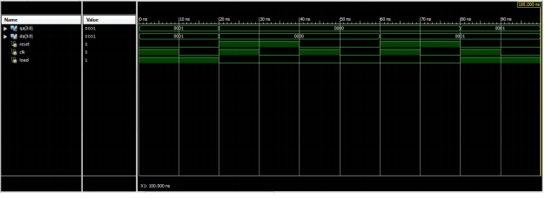

## Source Code: D Flip-Flop B

--Author: Xue Eric Lee

--Date: 4/10/2018

--File Name: dffb.v

--Purpose of Code:D flip flop to shift register to the right one bit.

--Project Part Number: Part 2c

module dffb (clk, clr, load, sft, db, qb);

input clk, clr, load, sft;

input [4:0] db;

output [4:0] qb;

reg [4:0] qb;

always@(posedge clr or posedge clk)

begin

if(clr) qb <= 0;

else if (load)

qb <= db;

else if (sft)

//qb <= { 1'b0, qb[3:1] };

begin

qb[5]<= 1'b0;

qb[3] <= qb[4];

qb[2] <= qb[3];

qb[1] <= qb[2];

qb[0] <= qb[1];

end

end

endmodule

## Source Code: FSM

--Author: Xue Eric Lee

--Date: 4/10/2018

--File Name: fsm.v

--Purpose of Code: Shows the finite state machine and the steps to take in order to load shift add, and clear registers for the sequential multiplier.

--Project Part Number: Part 2d

module fsm(reset, clk, clr, load_ab, load_p, shf_b, shf_p, en_add);

input reset, clk;

output clr, load_ab, load_p, shf_b, shf_p, en_add;

reg clr, load_ab, load_p, shf_b, shf_p, en_add;

reg[4:0] cs, nexts;

parameter s_clr = 5'b00000,

s_load_ab = 5'b00001,

s_en_add1 = 5'b00010,

s_load_p1 = 5'b00011,

s_shf_p1 = 5'b00100,

s_shf_b1 = 5'b00101,

s_en_add2 = 5'b00110,

s_load_p2 = 5'b00111,

s_shf_p2 = 5'b01000,

s_shf_b2 = 5'b01001,

s_en_add3 = 5'b01010,

s_load_p3 = 5'b01011,

s_shf_p3 = 5'b01100,

s_shf_b3 = 5'b01101,

s_en_add4 = 5'b01110,

s_load_p4 = 5'b01111,

s_shf_p4 = 5'b10000,

s_wait = 5'b10001;

always @ (posedge clk or posedge reset)

begin

if(reset) cs <= s_clr;

else cs <= nexts;

end

always @ (cs)

begin

case(cs)

s_clr : nexts = s_load_ab;

s_load_ab : nexts = s_en_add1;

s_en_add1 : nexts = s_load_p1;

s_load_p1 : nexts = s_shf_p1;

s_shf_p1 : nexts = s_shf_b1;

s_shf_b1 : nexts = s_en_add2;

s_en_add2 : nexts = s_load_p2;

s_load_p2 : nexts = s_shf_p2;

s_shf_p2 : nexts = s_shf_b2;

s_shf_b2 : nexts = s_en_add3;

s_en_add3 : nexts = s_load_p3;

s_load_p3 : nexts = s_shf_p3;

s_shf_p3 : nexts = s_shf_b3;

s_shf_b3 : nexts = s_en_add4;

s_en_add4 : nexts = s_load_p4;

s_load_p4 : nexts = s_shf_p4;

s_shf_p4: nexts = s_wait;

s_wait: nexts = s_wait;

default : nexts = s_clr;

endcase

end

always @ (cs)

begin

case(cs)

s_clr:

begin

clr = 1;

load_ab = 0;

load_p = 0;

shf_b = 0;

shf_p = 0;

en_add = 0;

end

s_load_ab:

begin

clr = 0;

load_ab = 1;

load_p = 0;

shf_b = 0;

shf_p = 0;

en_add = 0;

end

s_en_add1:

begin

clr = 0;

load_ab = 0;

load_p = 0;

shf_b = 0;

shf_p = 0;

en_add = 1;

end

s_load_p1:

begin

clr = 0;

load_ab = 0;

load_p = 1;

shf_b = 0;

shf_p = 0;

en_add = 0;

end

s_shf_p1:

begin

clr = 0;

load_ab = 0;

load_p = 0;

shf_b = 0;

shf_p = 1;

en_add = 0;

end

s_shf_b1:

begin

clr = 0;

load_ab = 0;

load_p = 0;

shf_b = 1;

shf_p = 0;

en_add = 0;

end

s_en_add2:

begin

clr = 0;

load_ab = 0;

load_p = 0;

shf_b = 0;

shf_p = 0;

en_add = 1;

end

s_load_p2:

begin

clr = 0;

load_ab = 0;

load_p = 1;

shf_b = 0;

shf_p = 0;

en_add = 0;

end

s_shf_p2:

begin

clr = 0;

load_ab = 0;

load_p = 0;

shf_b = 0;

shf_p = 1;

en_add = 0;

end

s_shf_b2:

begin

clr = 0;

load_ab = 0;

load_p = 0;

shf_b = 1;

shf_p = 0;

en_add = 0;

end

s_en_add3:

begin

clr = 0;

load_ab = 0;

load_p = 0;

shf_b = 0;

shf_p = 0;

en_add = 1;

end

s_load_p3:

begin

clr = 0;

load_ab = 0;

load_p = 1;

shf_b = 0;

shf_p = 0;

en_add = 0;

end

s_shf_p3:

begin

clr = 0;

load_ab = 0;

load_p = 0;

shf_b = 0;

shf_p = 1;

en_add = 0;

end

s_shf_b3:

begin

clr = 0;

load_ab = 0;

load_p = 0;

shf_b = 1;

shf_p = 0;

en_add = 0;

end

s_en_add4:

begin

clr = 0;

load_ab = 0;

load_p = 0;

shf_b = 0;

shf_p = 0;

en_add = 1;

end

s_load_p4:

begin

clr = 0;

load_ab = 0;

load_p = 1;

shf_b = 0;

shf_p = 0;

en_add = 0;

end

s_shf_p4:

begin

clr = 0;

load_ab = 0;

load_p = 0;

shf_b = 0;

shf_p = 1;

en_add = 0;

end

s_wait:

begin

clr = 0;

load_ab = 0;

load_p = 0;

shf_b = 0;

shf_p = 0;

en_add = 0;

end

default:

begin

clr = 0;

load_ab = 0;

load_p = 0;

shf_b = 0;

shf_p = 0;

en_add = 0;

end

endcase

end

endmodule

--Author: Xue Eric Lee

--Date: 4/10/2018

--File Name: fsm_tb.v

--Purpose of Code: test fsm.v

--Project Part Number: Part 2d

module fsm_tb;

// Inputs

reg reset;

reg clk;

// Outputs

wire clr;

wire load_ab;

wire load_p;

wire shf_b;

wire shf_p;

wire en_add;

// Instantiate the Unit Under Test (UUT)

fsm uut (

.reset(reset),

.clk(clk),

.clr(clr),

.load_ab(load_ab),

.load_p(load_p),

.shf_b(shf_b),

.shf_p(shf_p),

.en_add(en_add)

);

initial clk = 0;

always #10 clk = ~clk;

initial

begin

reset = 1;

#10;

reset = 0;

#10;

#400 $stop;

end

endmodule

Simulation Waveform:

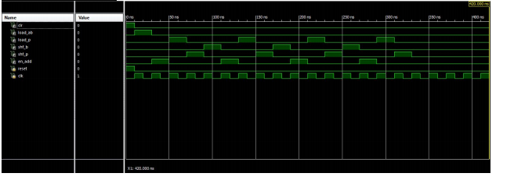

## Source code: Mult (Multiplier)

--Author: Xue Eric Lee

--Date: 4/10/2018

--File Name: mult.v

--Purpose of Code: The design that connects dffa, dffb, mux, adder, and preregister.

--Project Part Number: Part 2e

`timescale 1ns / 1ps

//////////////////////////////////////////////////////////////////////////////////

// Company:

// Engineer:

//

// Create Date: 02/14/2018 02:32:01 PM

// Design Name:

// Module Name: mult

// Project Name:

// Target Devices:

// Tool Versions:

// Description:

//

// Dependencies:

//

// Revision:

// Revision 0.01 - File Created

// Additional Comments:

//

//////////////////////////////////////////////////////////////////////////////////

module mult(display,multicand,multiplier,RST,P, CLK,shft_con,ld1,ld2,loadP,dispA,dispB,shftP,dispMulti,dispMultc);

output [3:0] dispA,dispB,dispMulti,dispMultc;

input [3:0] multicand;

input [4:0] multiplier;

input RST, CLK, shft_con, ld1,ld2,loadP,shftP;

wire [3:0] j,l,n;

wire [4:0] k;

wire [3:0] m;

wire s;

output [7:0]display;

//assign l = 4'b0111;

assign l = P[7:4];

output [7:0] P;

dffa load1(.clk(CLK),.clr(RST),.da(multicand),.load(ld1),.qa(j));

dffb load2(.clk(CLK),.clr(RST),.db(multiplier),.qb(k),.sft(shft_con),.load(ld2));

mux choose1(.s(k[0]),.d1(4'b0000),.d0(j),.y(n));

adder add1(.a(l),.b(n),.cout(s),.s(m));

shiftp shift1(.RST(RST),.CLK(CLK),.mostsig(s),.data_in(m),.shift_sig(shftP),.loadP(loadP),.prod(P));

assign dispMultc = j;

assign dispMulti = k;

assign dispA = n;

assign dispB = m;

assign display = l;

Endmodule

## Source code: Mux

--Author: Xue Eric Lee

--Date: 4/10/2018

--File Name: mux.v

--Purpose of Code: Chooses the value for y depending on whether the value is 1 or a 0.

--Project Part Number: Part 2f

module mux ( a, b, y);

input b;

input[3:0] a;

wire[3:0] z;

assign z = 4'b0000;

output[3:0] y;

reg[3:0] y;

always @ (a or b or z)

begin

case(b)

0 : y = z;

1 : y = a;

endcase

end

endmodule

Source code: P-Register

--Author: Xue Eric Lee

--Date: 4/10/2018

--File Name: preg.v

--Purpose of Code: The p-register stores the value of the multiplier.

--Project Part Number: Part 2g

module preg(clk, reset, load, shift, cin, din_p, p, ph);

input clk, reset, load, shift, cin;

input[3:0] din_p;

output[7:0] p;

output[3:0] ph;

reg[3:0] ph, pl;

always @ (posedge clk or posedge reset)

begin

if (reset)

ph <= 4'h0;

else if (load)

ph <= din_p;

else if (shift)

ph <= { cin , ph[3:1] };

end

always @ (posedge clk or posedge reset)

begin

if (reset)

pl <= 4'h0;

else if (shift)

pl <= { ph[0] , pl[3:1] };

end

assign p = {ph, pl};

endmodule

## Source code: Top Module

--Author: Xue Eric Lee

--Date: 4/10/2018

--File Name: top.v

--Purpose of Code: The top layer that combines all the code into one top module.

--Project Part Number: Part 2h

module top(a, b, p, clk, clr);

/*

testx, testy, testm, testn, testz, testr

*/

input[3:0] a, b;

input clk, clr;

output[7:0] p;

wire j, k, l, m, n, o, q;

//create one instance for finite state machine

fsm f1(.reset(clr), .clk(clk), .clr(q), .load_ab(j), .load_p(k), .shf_b(m), .shf_p(n), .en_add(o));

//create one instance for multiplier logic circuit

mult m1(.a(a), .b(b), .p(p), .reset(q), .clk(clk), .load_ab(j), .load_p(k), .shf_b(m), .shf_p(n), .en_add(o) );

endmodule

User Constraints File: 4 by 4 Binary Sequential Multiplier Design

set_property -dict { PACKAGE_PIN E3 IOSTANDARD LVCMOS33 } [get_ports { clk }]; #IO_L12P_T1_MRCC_35 Sch=clk100mhz

set_property -dict { PACKAGE_PIN J15 IOSTANDARD LVCMOS33 } [get_ports { a[0]}]; #IO_L24N_T3_RS0_15 Sch=sw[0]

set_property -dict { PACKAGE_PIN L16 IOSTANDARD LVCMOS33 } [get_ports { a[1]}]; #IO_L3N_T0_DQS_EMCCLK_14 Sch=sw[1]

set_property -dict { PACKAGE_PIN M13 IOSTANDARD LVCMOS33 } [get_ports { a[2] }]; #IO_L6N_T0_D08_VREF_14 Sch=sw[2]

set_property -dict { PACKAGE_PIN R15 IOSTANDARD LVCMOS33 } [get_ports { a[3] }]; #IO_L13N_T2_MRCC_14 Sch=sw[3]

set_property -dict { PACKAGE_PIN H17 IOSTANDARD LVCMOS33 } [get_ports { p[0] }]; #IO_L18P_T2_A24_15 Sch=led[0]  
set_property -dict { PACKAGE_PIN K15 IOSTANDARD LVCMOS33 } [get_ports { p[1]}]; #IO_L24P_T3_RS1_15 Sch=led[1]  
set_property -dict { PACKAGE_PIN J13 IOSTANDARD LVCMOS33 } [get_ports { p[2] }]; #IO_L17N_T2_A25_15 Sch=led[2]  
set_property -dict { PACKAGE_PIN N14 IOSTANDARD LVCMOS33 } [get_ports { p[3] }]; #IO_L8P_T1_D11_14 Sch=led[3]  
set_property -dict { PACKAGE_PIN R18 IOSTANDARD LVCMOS33 } [get_ports { p[4]}]; #IO_L7P_T1_D09_14 Sch=led[4]  
set_property -dict { PACKAGE_PIN V17 IOSTANDARD LVCMOS33 } [get_ports { p[5] }]; #IO_L18N_T2_A11_D27_14 Sch=led[5]  
set_property -dict { PACKAGE_PIN U17 IOSTANDARD LVCMOS33 } [get_ports { p[6] }]; #IO_L17P_T2_A14_D30_14 Sch=led[6]  
set_property -dict { PACKAGE_PIN U16 IOSTANDARD LVCMOS33 } [get_ports { p[7] }]; #IO_L18P_T2_A12_D28_14 Sch=led[7]

set_property -dict { PACKAGE_PIN N17 IOSTANDARD LVCMOS33 } [get_ports { clr }]; #IO_L9P_T1_DQS_14 Sch=btnc

Results:

By far our most frustrating and longest part of the lab. Because we got stuck on this lab, it took us almost the whole semester to complete. With this part of the lab, we got very close but just couldn’t find what was wrong with it. Because it is a multi layer design, troubleshooting our code was extremely tedious. We were even getting errors in areas even from codes that were provided to us from the professor. In part 2, we were having trouble with the sequential multiplier not registering our values correctly. We had the shift registers and everything working great but were being off one or two values. We found that it had to do with pre registering the values inside of P. To overcome this problem, we made a separate design and incorporated it into our top level to pre register our values.

# Part 3: LCD

## Source Code: LCD

--Author: Xue Eric Lee

--Date: 4/10/2018

--File Name: fpga_proj.v

--Purpose of Code: The design gives a signal to the LCD to perform the display of cpe 166.

--Project Part Number: Part 3

module fpga_proj( clk, seg, dig);

input clk;

output [7:0] seg;

output [7:0] dig;

parameter N = 18;

reg [N-1:0] count;

reg [3:0] dd;

reg [7:0] seg;

reg [7:0] an;

always @ (posedge clk)

begin

count <= count + 1;

case(count[N-1:N-3])

3'b000 :

begin

dd = 4'd7;

an = 8'b11111110;

end

3'b001:

begin

dd = 4'd6;

an = 8'b11111101;

end

3'b010:

begin

dd = 4'd5;

an = 8'b11111011;

end

3'b011:

begin

dd = 4'd4;

an = 8'b11110111;

end

3'b100 :

begin

dd = 4'd3;

an = 8'b11101111;

end

3'b101:

begin

dd = 4'd2;

an = 8'b11011111;

end

3'b110:

begin

dd = 4'd1;

an = 8'b10111111;

end

3'b111:

begin

dd = 4'd0;

an = 8'b01111111;

end

endcase

end

assign dig = an;

always @ (dd)

begin

seg[7] = 1'b1;

case(dd)

4'd0 : seg[6:0] = 7'b1000110; //to display C

4'd1 : seg[6:0] = 7'b0001100; //to display P

4'd2 : seg[6:0] = 7'b0000110; //to display E

4'd3 : seg[6:0] = 7'b1111001; //to display 1

4'd4 : seg[6:0] = 7'b0000010; //to display 6

4'd5 : seg[6:0] = 7'b0000010; //to display 6

4'd6 : seg[6:0] = 7'b0001001; //to display X

4'd7 : seg[6:0] = 7'b1000111; //to display L

default : seg[6:0] = 7'b1111111; //blank

endcase

end

endmodule

User Constraints File: LCD

set_property -dict { PACKAGE_PIN E3 IOSTANDARD LVCMOS33 } [get_ports { clk }]; #IO_L12P_T1_MRCC_35 Sch=clk100mhz

create_clock -add -name sys_clk_pin -period 10.00 -waveform {0 5} [get_ports { clk }];

## segment display

set_property -dict { PACKAGE_PIN T10 IOSTANDARD LVCMOS33 } [get_ports { seg[0] }]; #IO_L24N_T3_A00_D16_14 Sch=ca

set_property -dict { PACKAGE_PIN R10 IOSTANDARD LVCMOS33 } [get_ports { seg[1] }]; #IO_25_14 Sch=cb

set_property -dict { PACKAGE_PIN K16 IOSTANDARD LVCMOS33 } [get_ports { seg[2] }]; #IO_25_15 Sch=cc

set_property -dict { PACKAGE_PIN K13 IOSTANDARD LVCMOS33 } [get_ports { seg[3] }]; #IO_L17P_T2_A26_15 Sch=cd

set_property -dict { PACKAGE_PIN P15 IOSTANDARD LVCMOS33 } [get_ports { seg[4] }]; #IO_L13P_T2_MRCC_14 Sch=ce

set_property -dict { PACKAGE_PIN T11 IOSTANDARD LVCMOS33 } [get_ports { seg[5] }]; #IO_L19P_T3_A10_D26_14 Sch=cf

set_property -dict { PACKAGE_PIN L18 IOSTANDARD LVCMOS33 } [get_ports { seg[6] }]; #IO_L4P_T0_D04_14 Sch=cg

set_property -dict { PACKAGE_PIN H15 IOSTANDARD LVCMOS33 } [get_ports { seg[7] }]; #IO_L19N_T3_A21_VREF_15 Sch=dp

set_property -dict { PACKAGE_PIN J17 IOSTANDARD LVCMOS33 } [get_ports { dig[0] }]; #IO_L23P_T3_FOE_B_15 Sch=an[0]

set_property -dict { PACKAGE_PIN J18 IOSTANDARD LVCMOS33 } [get_ports { dig[1] }]; #IO_L23N_T3_FWE_B_15 Sch=an[1]

set_property -dict { PACKAGE_PIN T9 IOSTANDARD LVCMOS33 } [get_ports { dig[2] }]; #IO_L24P_T3_A01_D17_14 Sch=an[2]

set_property -dict { PACKAGE_PIN J14 IOSTANDARD LVCMOS33 } [get_ports { dig[3] }]; #IO_L19P_T3_A22_15 Sch=an[3]

set_property -dict { PACKAGE_PIN P14 IOSTANDARD LVCMOS33 } [get_ports { dig[4] }]; #IO_L8N_T1_D12_14 Sch=an[4]

set_property -dict { PACKAGE_PIN T14 IOSTANDARD LVCMOS33 } [get_ports { dig[5] }]; #IO_L14P_T2_SRCC_14 Sch=an[5]

set_property -dict { PACKAGE_PIN K2 IOSTANDARD LVCMOS33 } [get_ports { dig[6] }]; #IO_L23P_T3_35 Sch=an[6]

set_property -dict { PACKAGE_PIN U13 IOSTANDARD LVCMOS33 } [get_ports { dig[7] }]; #IO_L23N_T3_A02_D18_14 Sch=an[7]

Results:

In this part of the lab, we had to display CPE 166 onto the LCD board. We were able to achieve with not very much problems as we were supplied a template from the professor and we just had to change up a few things and then write the constraints file for the board. It was actually pretty easy and did not take much time to accomplish this part of the lab.

# Conclusion:

This lab overall served as an introduction to the Verilog programming language. The code required making logic gate assignments, creating time dependent modules such as d flip flops, linking modules together in hierarchical design and using case statements to create a finite state machine. Test benches for all the modules also needed to be designed in Verilog. Inputs and outputs needed to be declared in a certain way, the tested module needed to be called in a certain fashion. For the sequential multiplier, a clock needed to be made for the simulation, as well as learning how to make the simulation wait certain periods before assigning more inputs. The concepts of the combinational design versus sequential were also explored. The advantage of a combinational design is that is does not require a clock, but they can also be messy to organize. The advantage of a sequential design is that while they require a clock, managing the connected modules is an easier task.